This update or document of informant is for people that have asked about the MISRC platforms V2.5 update, this may not be the most current nor up-to-date document (within 12/24 hour frames) but until the official release this document will provide a concise source of images and details in one link I can copy and paste and save my thumbs some lifespan.

V2.5 feature list

- New Input filter, clean 20mhz range with no aliasing.
- Reworked DIPS.
- Proper config tables accurate to hardware and firmware.
- New Clock circuit, enough power to drive several units potentially.
- Practical input and output capability on a dedicated SMA for clock.
- Dedicated 4ch audio via 2x PCM1802 with inputs designed to cope for a wide range of consumer sources.
- New Clipping indicator system, now real-time resetting like a standard audio interface.
- Input and output ports are now conforming to front and back sides for casing.

Software

- 12-bit FLAC and 8-bit FLAC/RAW modes
- 4ch native audio capture wiring for PCM1802 chips (4ch 78.1khz 24-bit “.wav”)
- Stereo and Mono Single channel audio selection
- Real-time resampling (for 5/10/20msps and more options)
- Levels monitoring of RF gain/noise in CLI/GUI

New cross platform GUI front end for misrc_capture allowing for visual gain/dc offset control adjustments and inspection & test decoding of signals in real-time, including implemented cvbs-decoding, sync trigger features.

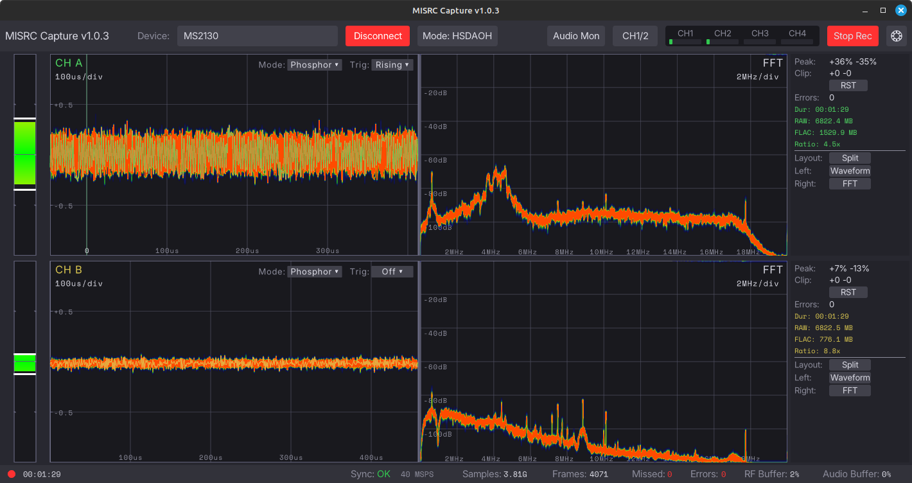
MISRC Capture - GUI

Currently being tested and developed on Linux Mint 21.2, MacOS 15, Windows 10

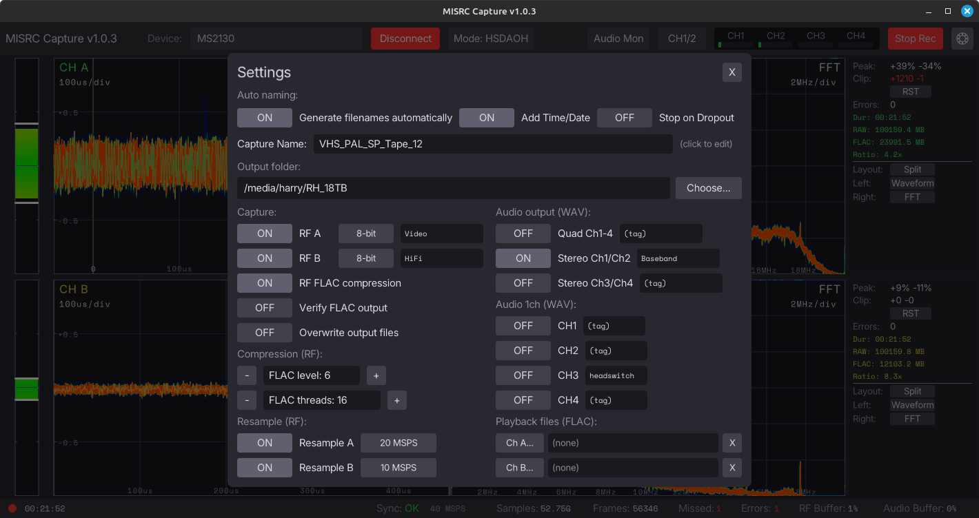
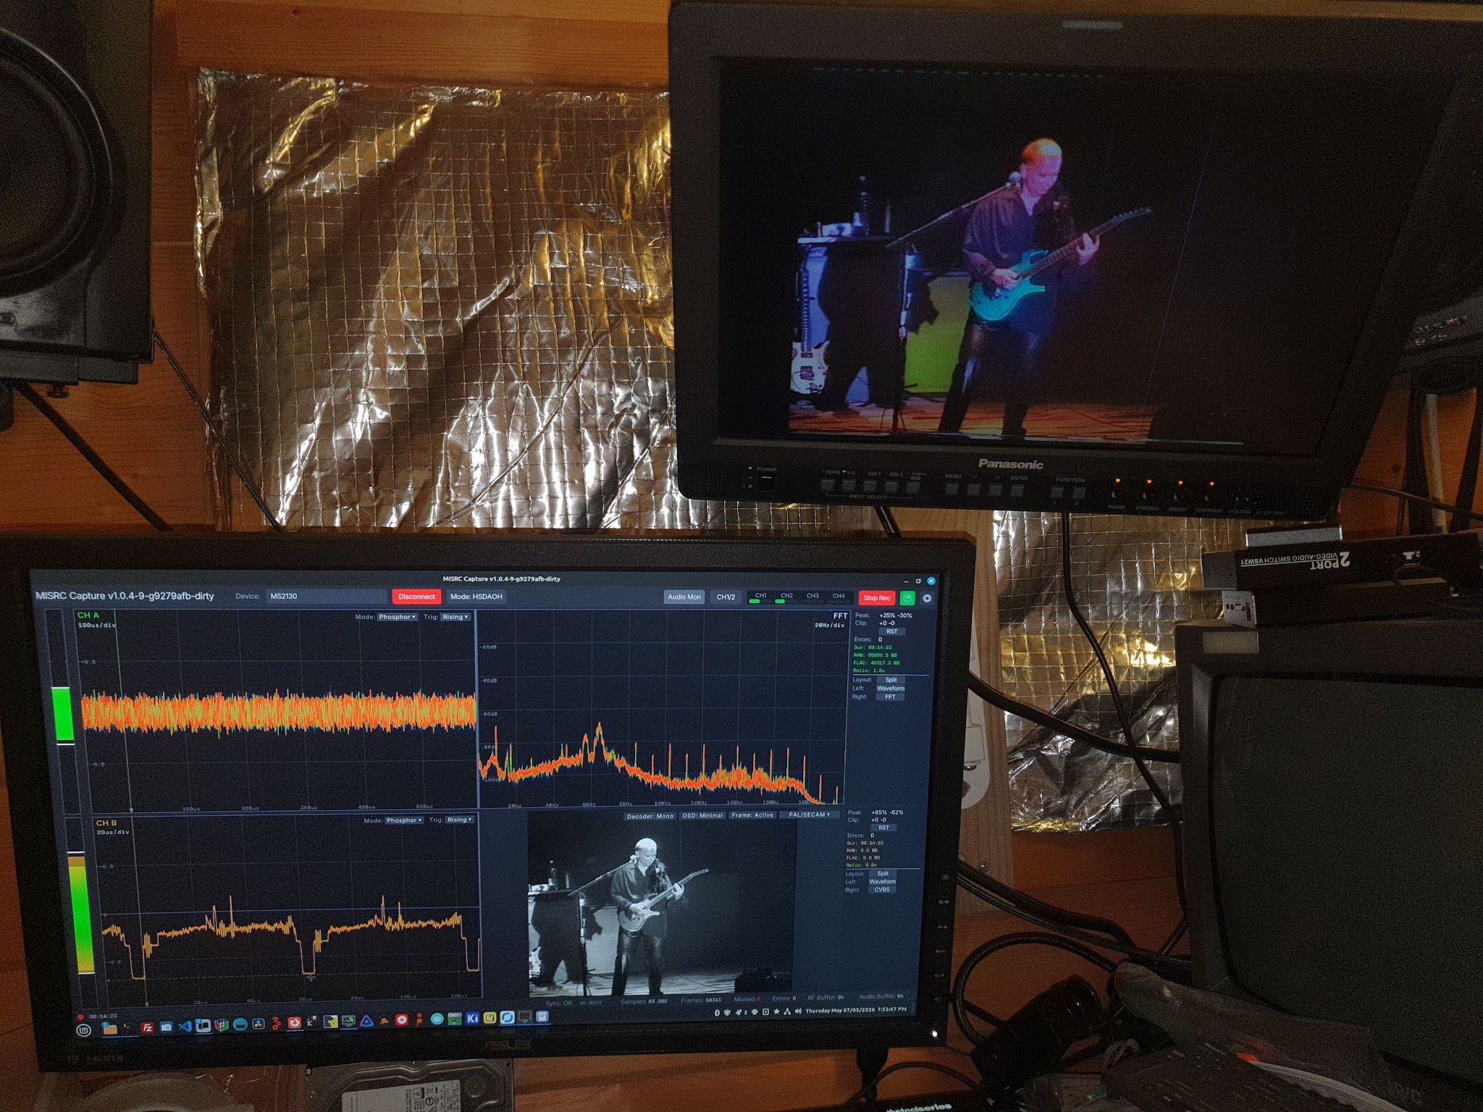

Example of Hi8 with real-time CVBS Luma decoding alongside RF capture and audio capture.

MISRC V2.5 PCB

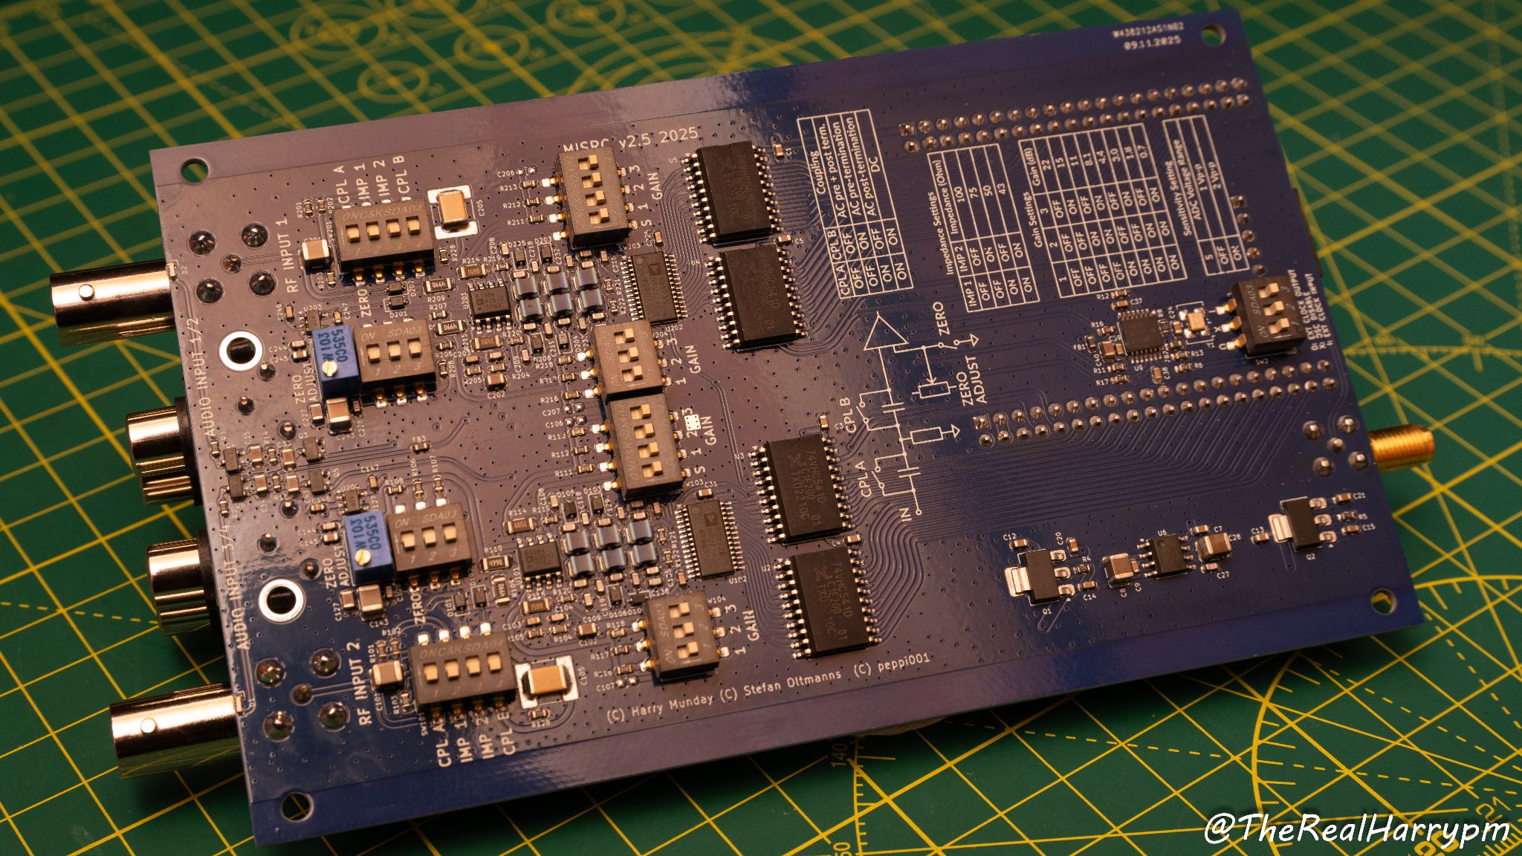

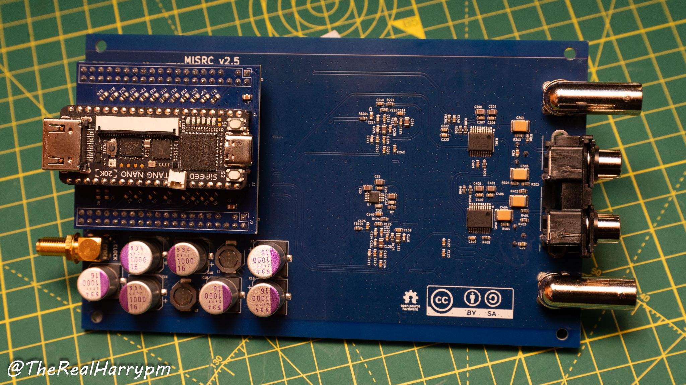

MISRC V2.5 & Case Photos

Overview

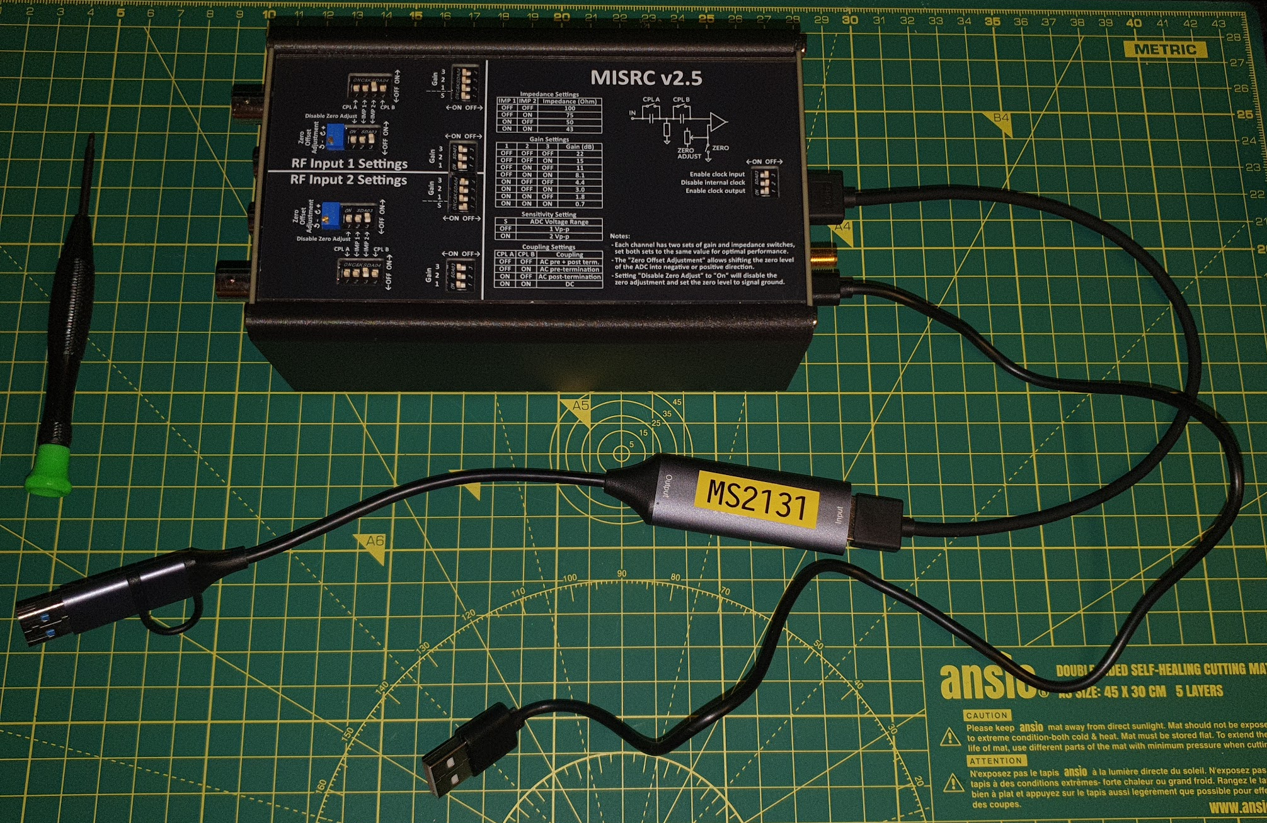

Internal
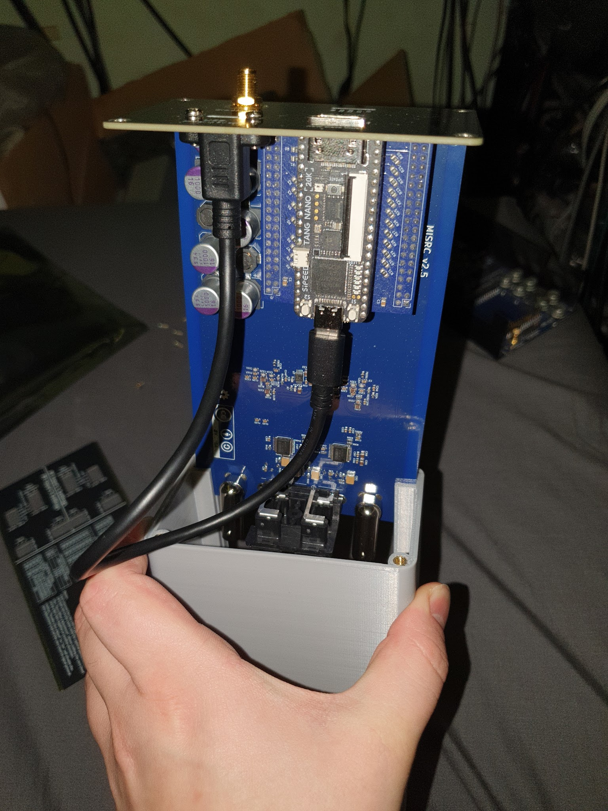

Top

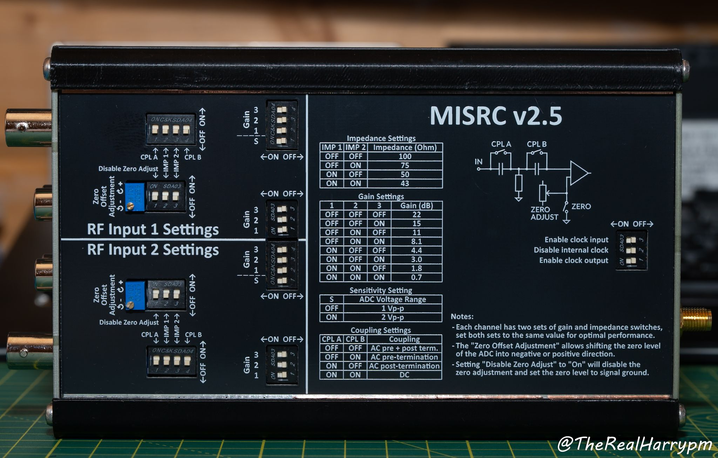

Front
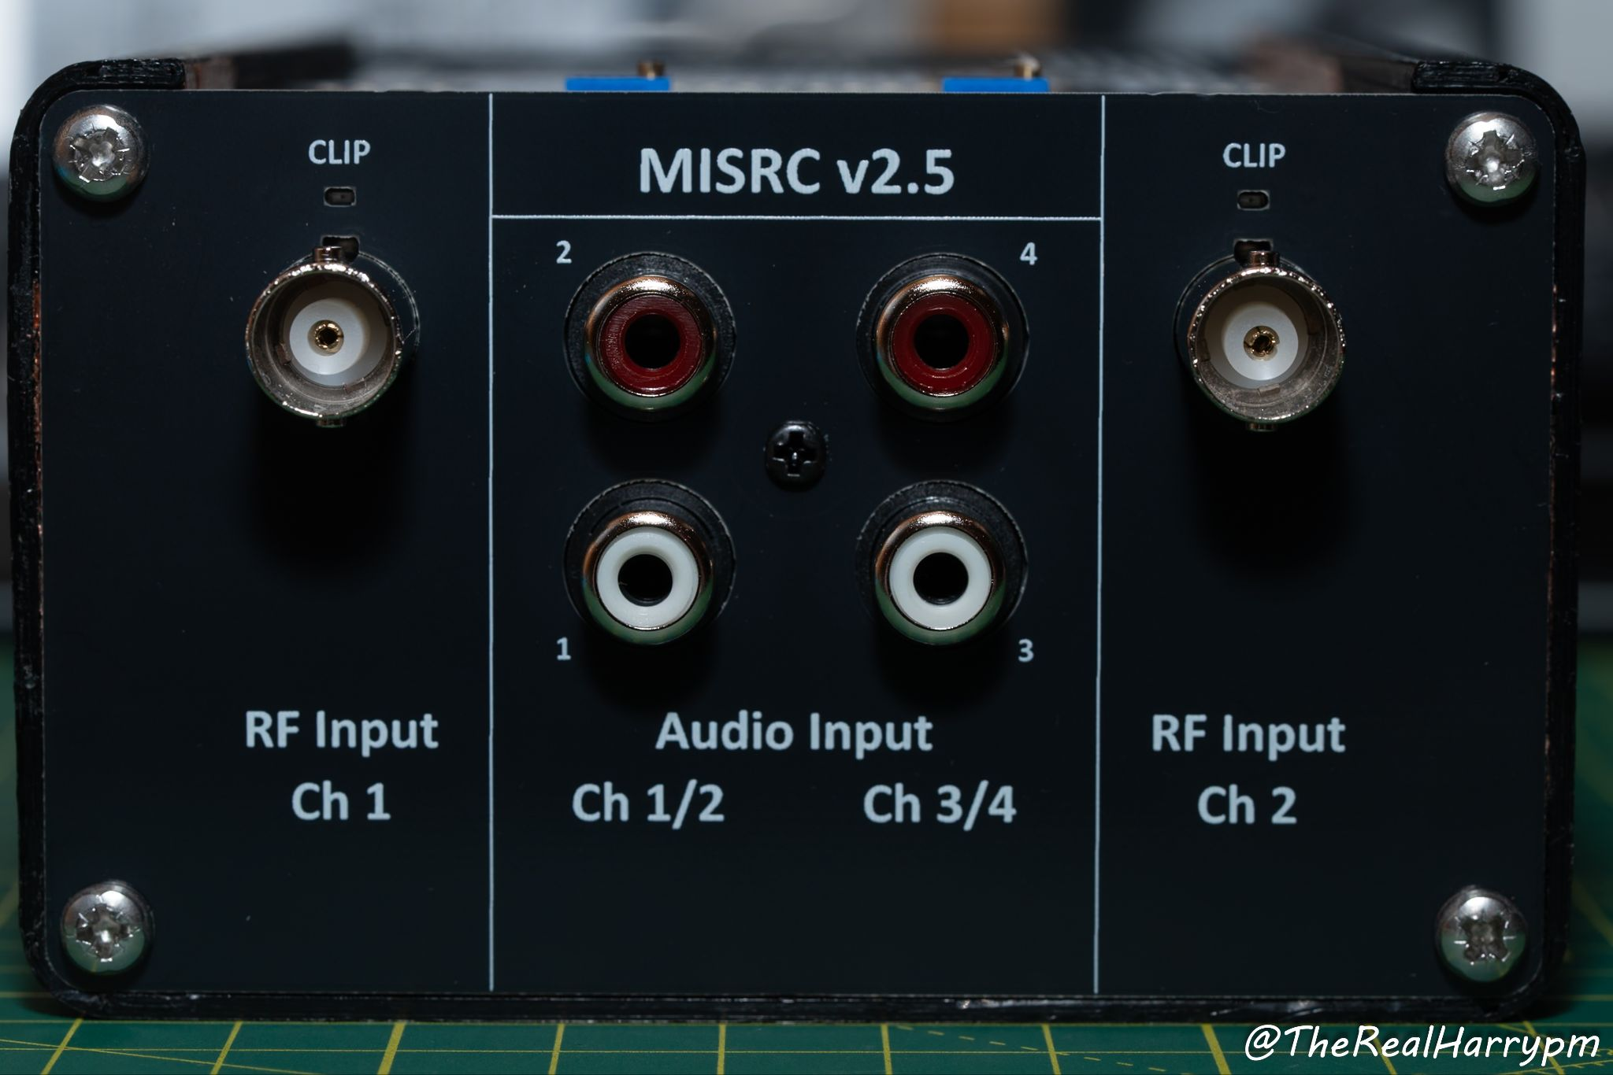

Back

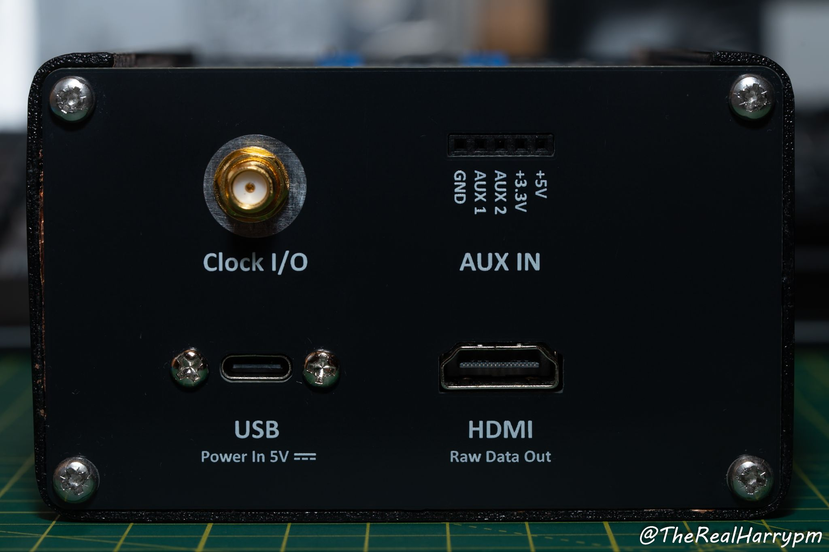

Current Work’s (Jan 2026)
- Testing USB 3.0 to 3.2 Gen 2 controller support
- Testing alternative FX3 firmware ideas

March 2026
- Procurement for parts begins for continued v1.5a and v2.5 production
- 3D Printed case core finished
May 2026
- MISRC GUI stability testing and improvements

